IRIS FLOWER PREDICTION SYSTEM
Machine Learning Web Application using Flask

Table of Content
S.no | Contents | Page no
1 | Acknowledgements | 2
2 | Project Overview | 2
3 | Dataset Description | 3
4 | Project Structure | 4
5 | Technology Stack | 5
6 | Implementation Steps | 5
7 | Code Explanation | 6-8
8 | Model Development | 8-9
9 | Deployment Process | 9-11
10 | Results and Output | 11-13
11 | Challenges and Solutions | 14-15
12 | Future Enhancements | 15
13 | Conclusion | 16
14 | References | 16-17

1. Acknowledgements
I would like to express my sincere gratitude to everyone who supported and guided me throughout the development of the Iris Flower Prediction System.
I would like to thank my trainer and mentors for their valuable guidance in understanding Machine Learning concepts and practical implementation using Python and Flask.
I also acknowledge the creators of the famous Iris dataset, which has been widely used for academic and research purposes in machine learning.
Finally, I would like to thank open-source communities and documentation resources that helped me successfully complete this project.

2. Project Overview
The Iris Flower Prediction System is a Machine Learning web application developed using Python and Flask.
The main objective of this project is to predict the species of an Iris flower based on four input features:
- Sepal Length
- Sepal Width
- Petal Length
- Petal Width
The system allows users to:
- Enter flower measurements
- Select a Machine Learning model
- Predict the flower species
- View detailed performance metrics including:
  - Train Accuracy
  - Test Accuracy
  - Confusion Matrix
  - Classification Report
This project demonstrates the integration of:
- Machine Learning Model Training
- Model Serialization
- Web Application Development
- Performance Visualization
The final output is a fully functional web-based prediction system.

3. Dataset Description
The dataset used in this project is the Iris Dataset, one of the most famous datasets in Machine Learning.
Dataset Features
Feature Name | Description
SepalLengthCm | Length of sepal (cm)
SepalWidthCm | Width of sepal (cm)
PetalLengthCm | Length of petal (cm)
PetalWidthCm | Width of petal (cm)
Target Classes
The dataset contains three flower species:
- Iris Setosa
- Iris Versicolor
- Iris Virginica
Dataset Characteristics
- Total Samples: 150
- Classes: 3
- Features: 4
- Balanced dataset (50 samples per class)
The dataset is ideal for classification problems and beginner-level machine learning projects.

4. Project Structure
The project follows a clean modular folder structure for better organization and scalability.
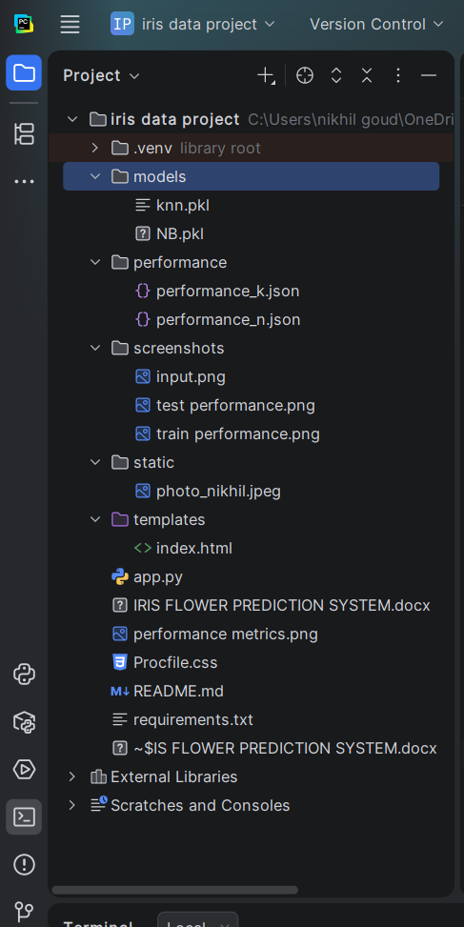

Data Flow Diagram:
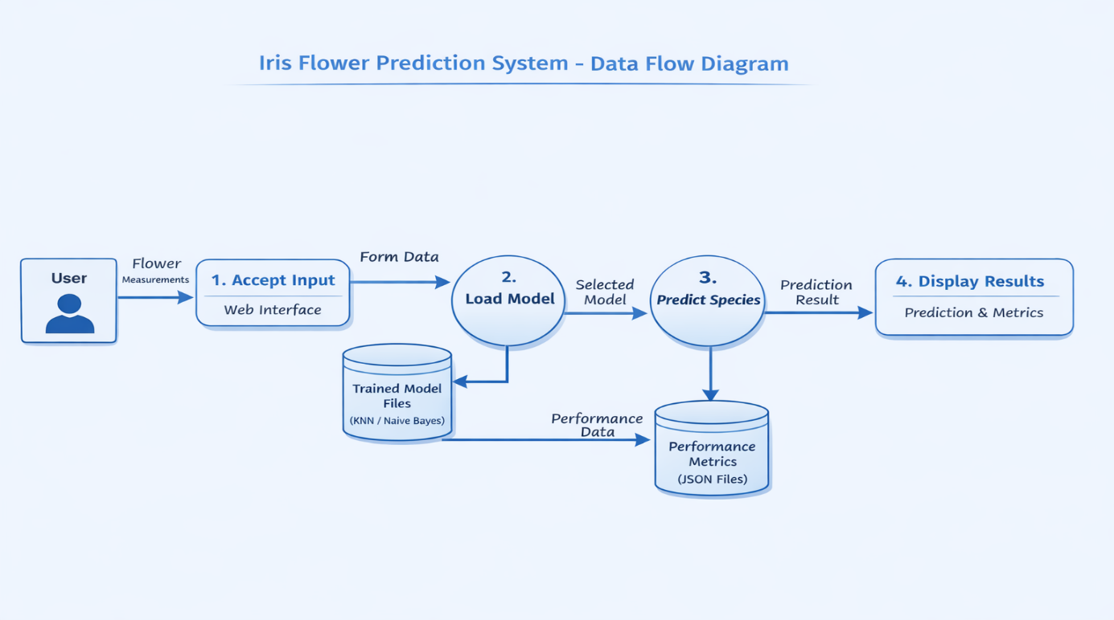
Description of Important Files
- train.py – Used to train machine learning models and save them
- app.py – Flask application that handles user input and prediction
- models/ – Stores trained model files
- performance/ – Stores model performance metrics
- templates/ – Contains HTML files
- static/ – Stores images and styling resources
This structure ensures separation between backend, frontend, and model components.
5. Technology Stack
The project uses the following technologies:
Programming Language
- Python 3.x
Machine Learning Libraries
- Scikit-learn
- Pandas
- NumPy
Web Framework
- Flask
Frontend
- HTML
- CSS
- Jinja2 Template Engine
Model Storage
- Pickle (.pkl files)
Data Storage for Performance
- JSON files
This combination allows seamless integration of machine learning models into a web-based interface.
6. Implementation Steps
The development of the Iris Flower Prediction System was carried out in a structured manner. The implementation process involved the following steps:
Step 1: Dataset Collection
The Iris dataset was obtained and loaded using Pandas. The dataset contains 150 samples with four input features and one target variable.
Step 2: Data Preprocessing
- Checked for missing values
- Verified data types
- Separated features (X) and target (y)
- Split dataset into training and testing sets using train_test_split()
Step 3: Model Training
Multiple machine learning models were trained including:
- K-Nearest Neighbors (KNN)
- Logistic Regression
- Support Vector Machine (SVM)
Each model was trained using the training dataset.
Step 4: Model Evaluation
After training, each model was evaluated using:
- Accuracy Score
- Confusion Matrix
- Classification Report
Performance metrics were saved into JSON files.
Step 5: Model Serialization
Trained models were saved using the Pickle library as .pkl files inside the models/ folder.
Step 6: Web Application Development
A Flask application was developed to:
- Accept user inputs
- Load selected model
- Predict flower species
- Display performance metrics
Step 7: Frontend Design
An interactive HTML interface was created using:
- Form inputs
- Model selection options
- Styled performance tables
- Profile section
Step 8: Integration
The backend (Flask) and frontend (HTML) were connected using Jinja templating.
7. Code Explanation
This file is responsible for training the machine learning models, evaluating them, and saving both the models and their performance metrics.
7.1 Loading and Preprocessing Data
df = pd.read_csv("Iris.csv")
df['Species'] = df['Species'].map({
'Iris-setosa': 0,
'Iris-versicolor': 1,
'Iris-virginica': 2
})
df = df.drop(['Id'], axis=1)
X = df.iloc[:, :4]
y = df.iloc[:, 4]
Explanation:
- Dataset is loaded using Pandas.
- Target labels are converted to numeric values.
- The Id column is removed.
- Features (X) and target (y) are separated.
7.2 Splitting the Dataset
from sklearn.model_selection import train_test_split

X_train, X_test, y_train, y_test = train_test_split(
X, y, test_size=0.2, random_state=42
)
Explanation:
The dataset is split into 80% training data and 20% testing data.
7.3 Training KNN Model
from sklearn.neighbors import KNeighborsClassifier

reg = KNeighborsClassifier(n_neighbors=5)
reg.fit(X_train, y_train)
Explanation:
K-Nearest Neighbors model is trained using the training dataset.
7.4 Evaluating Model Performance
from sklearn.metrics import accuracy_score, classification_report, confusion_matrix
train_accuracy = accuracy_score(y_train, reg.predict(X_train))
test_accuracy = accuracy_score(y_test, reg.predict(X_test))
classification_r = classification_report(y_test, reg.predict(X_test), output_dict=True)
confusion_m = confusion_matrix(y_test, reg.predict(X_test))
Explanation:
The model is evaluated using:
- Accuracy Score
- Classification Report
- Confusion Matrix
7.5 Training Naive Bayes Model
from sklearn.naive_bayes import GaussianNB
nav = GaussianNB()
nav.fit(X_train, y_train)
Explanation:
Gaussian Naive Bayes model is trained for comparison.
7.6 Saving Models
import pickle
pickle.dump(reg, open("knn.pkl", "wb"))
pickle.dump(nav, open("NB.pkl", "wb"))
Explanation:
Trained models are saved as .pkl files for later use in the Flask application.
7.7 Saving Performance Metrics
import json
json.dump(performance_k, open("performance_k.json", "w"), indent=4)
json.dump(performance_n, open("performance_n.json", "w"), indent=4)
Explanation:
Model performance metrics are saved in JSON format to display in the web interface.
8. Model Development
In this project, two machine learning classification algorithms were implemented and compared.
8.1 K-Nearest Neighbors (KNN)
KNN is a distance-based classification algorithm.
It classifies a new data point based on the majority class among its nearest neighbors.
Why KNN?
- Simple and easy to implement
- Works well on small datasets
- Suitable for multi-class classification
The optimal value of K was selected by testing multiple odd values and choosing the one with the highest test accuracy.
8.2 Gaussian Naive Bayes
Gaussian Naive Bayes is a probabilistic classification algorithm based on Bayes’ Theorem.
Why Naive Bayes?
- Fast computation
- Performs well with small datasets
- Works effectively for normally distributed data
Both models were evaluated using:
- Train Accuracy
- Test Accuracy
- Confusion Matrix
- Classification Report
The user can select the preferred model in the web interface.

9. Deployment Process
The Iris Flower Prediction system was deployed as a live web application using Render Cloud Platform and GitHub.
9.1 Local Development
Initially, the application was developed and tested locally using:
python app.py
The application ran on:
http://127.0.0.1:5000/
After successful local testing, the project was prepared for cloud deployment.
9.2 Preparing for Deployment
The following files were added for deployment:
- requirements.txt → Contains all required Python libraries
- Procfile → Specifies how to start the Flask app
- runtime.txt (optional) → Specifies Python version
Example Procfile:
web: gunicorn app:app
9.3 GitHub Integration
- The complete project was uploaded to a GitHub repository.
- The repository includes:
  - app.py
  - train.py
  - models folder
  - performance folder
  - templates folder
  - static folder
  - requirements.txt
GitHub serves as the version control system and deployment source.
9.4 Deployment on Render
Steps followed:
- Created an account on Render
- Selected New Web Service
- Connected GitHub repository
- Selected branch (main/master)
- Set build command:
- pip install -r requirements.txt
- Set start command:
- gunicorn app:app
- Deployed the application
After successful deployment, Render generated a public URL.
9.5 Live Application
The application is now accessible through a public URL provided by Render.
Users can:
- Enter flower measurements
- Select the model
- View prediction results
- Analyze train and test performance
This deployment makes the project accessible globally without requiring local installation.
10. Results and Output
The Iris Flower Prediction System was successfully developed and deployed as a web-based application. The system accurately predicts the species of an Iris flower based on user input features.
10.1 Input Interface
The application provides a user-friendly interface where users can:
- Enter Sepal Length
- Enter Sepal Width
- Enter Petal Length
- Enter Petal Width
- Select the desired Machine Learning model
- Click the Predict button

📌 Screenshot 1: Input Form Interface
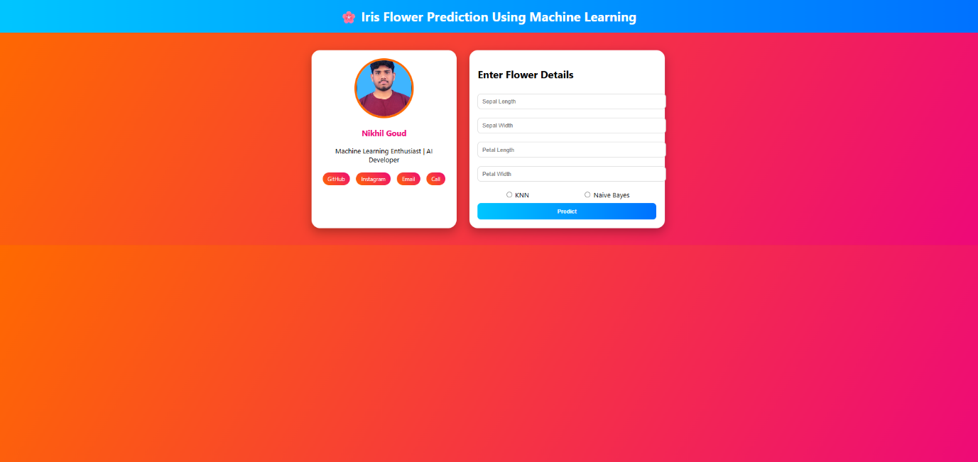

10.2 Prediction Output
After entering the values and selecting the model, the system displays:
- Predicted Flower Species
- Highlighted prediction result (green background)
The prediction result is dynamically generated using the selected trained model.
📌 Screenshot 2: Prediction Result Output
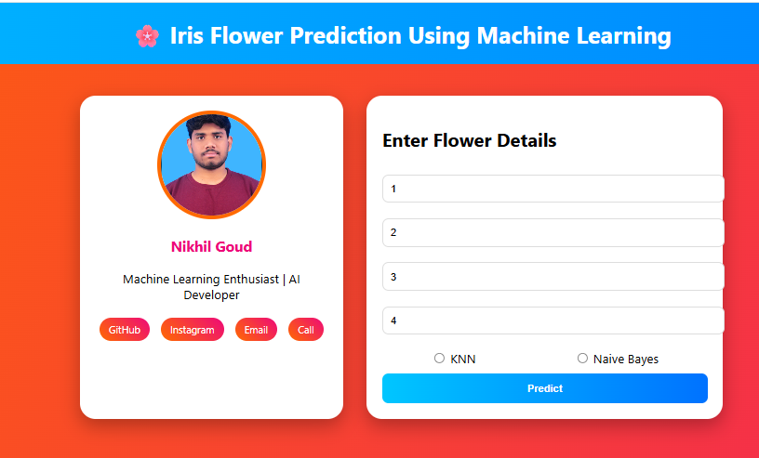
10.3 Train Performance Metrics
The system displays the following training performance metrics:
- Train Accuracy
- Train Confusion Matrix
- Train Classification Report (Precision, Recall, F1-score, Support)
These metrics help evaluate how well the model performed on training data.
📌 Screenshot 3: Train Performance Section
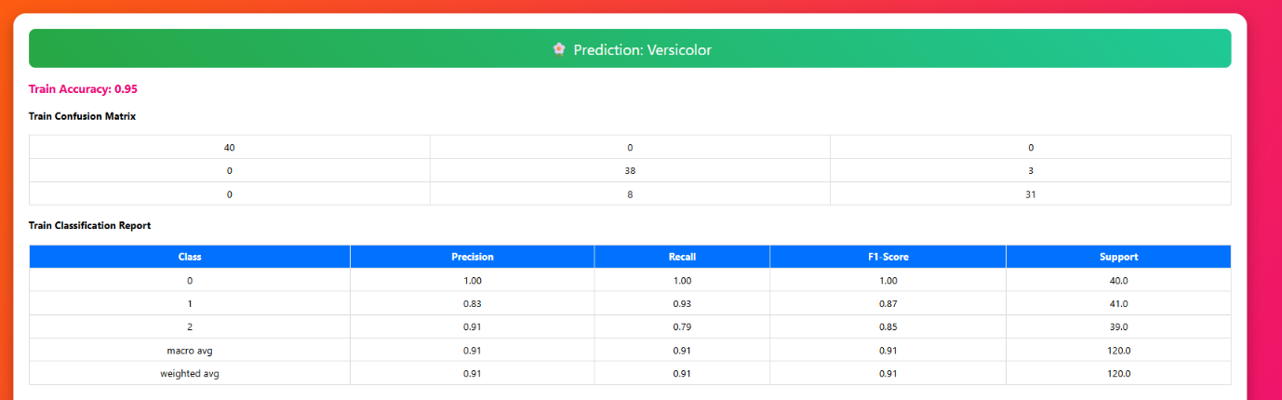

10.4 Test Performance Metrics
The application also displays testing performance metrics:
- Test Accuracy
- Test Confusion Matrix
- Test Classification Report
The test performance indicates how well the model generalizes to unseen data.
📌 Screenshot 4: Test Performance Section
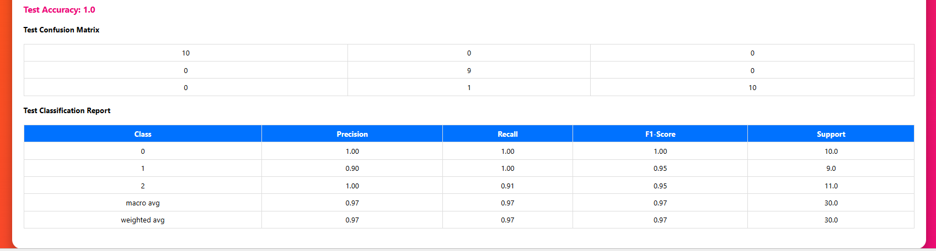

10.5 Model Comparison
Since multiple models are implemented (KNN and Naive Bayes), users can:
- Select different models
- Compare accuracy
- Observe changes in confusion matrix and classification report
This provides flexibility and demonstrates model evaluation concepts.
📌 Screenshot 5: Model Selection and Comparison
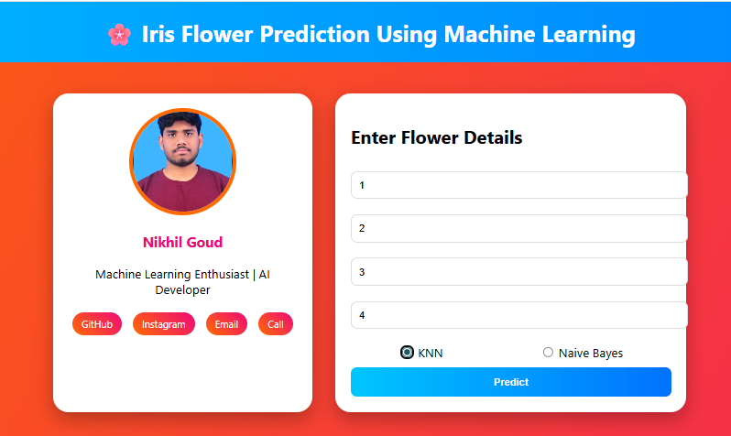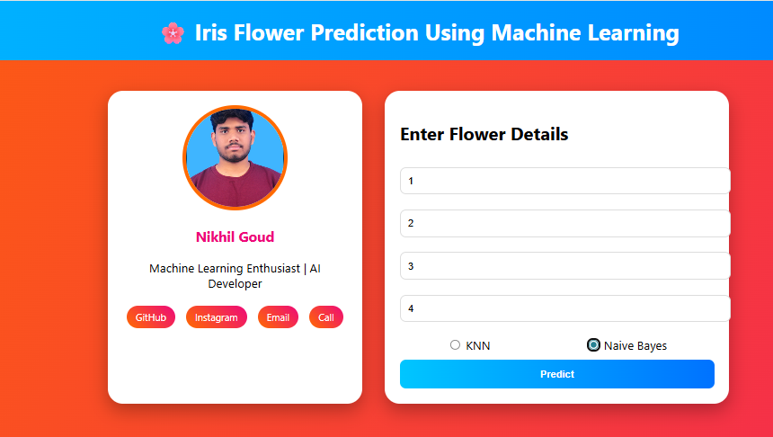

11. Challenges and Solutions
During the development of the Iris Flower Prediction System, several challenges were encountered. These challenges helped improve both technical and problem-solving skills.
Challenge 1: Feature Name Mismatch
Problem:
While predicting, an error occurred due to mismatch between training feature names and prediction feature names.
Solution:
Ensured that the feature column names used during prediction exactly matched the column names used during model training.
Challenge 2: Displaying Classification Report Properly
Problem:
The classification report was not displaying correctly in the HTML template due to dictionary key formatting issues (e.g., f1-score).
Solution:
Used dictionary-style access in Jinja templates:
value["f1-score"]
Also formatted values to two decimal places for better readability.
Challenge 3: Model Selection in Interface
Problem:
Initially, model selection was not user-friendly.
Solution:
Implemented side-by-side model selection options in the interface to improve user experience.
Challenge 4: Deployment Errors on Render
Problem:
Deployment required additional configuration such as:
- requirements.txt
- Procfile
- Proper start command
Solution:
Added necessary configuration files and used:
gunicorn app:app
as the start command.
Challenge 5: UI Design Improvements
Problem:
The initial interface looked simple and less attractive.
Solution:
Enhanced UI using:
- Gradient backgrounds
- Styled buttons
- Tabular performance reports
- Highlighted prediction output
- Professional profile section

12. Future Enhancements
Although the system is fully functional, several improvements can be implemented in future versions.
1. Add More Machine Learning Models
- Support Vector Machine (SVM)
- Random Forest
- Decision Tree
2. Add Data Visualization
- Accuracy comparison charts
- Confusion matrix heatmap
- Model performance graphs
3. Add Probability Prediction
Display probability percentage for each class.
4. User Authentication System
Allow users to log in and save prediction history.
5. Database Integration
Store predictions in a database for analytics.
6. Mobile Responsive Design
Improve UI responsiveness for mobile devices.
7. CI/CD Integration
Automate deployment using continuous integration pipelines.

13. Conclusion
The Iris Flower Prediction System successfully demonstrates the complete machine learning lifecycle:
- Data preprocessing
- Model training
- Model evaluation
- Model serialization
- Web integration using Flask
- Cloud deployment using Render
The system provides accurate predictions of Iris flower species based on user inputs and allows users to compare different machine learning models.
This project enhances understanding of:
- Supervised learning algorithms
- Model evaluation metrics
- Web application development
- Cloud deployment
Overall, the project serves as a strong foundation for building more advanced machine learning web applications.
14. References
- Fisher, R. A. (1936). The use of multiple measurements in taxonomic problems.
- Scikit-learn Documentation – https://scikit-learn.org
- Flask Documentation – https://flask.palletsprojects.com
- Render Documentation – https://render.com/docs
- Pandas Documentation – https://pandas.pydata.org
Tools and Platforms
- Development: PyCharm
- Version Control: Git, GitHub
- Deployment: Render
- Design: CSS Gradient Generators, Color Palette Tools

Project By: A. NIKHIL GOUD
Last Updated: 14-2-2026
Live Application: Project link
GitHub Repository: https://github.com/NikhilGoud601/irsi-project.git

